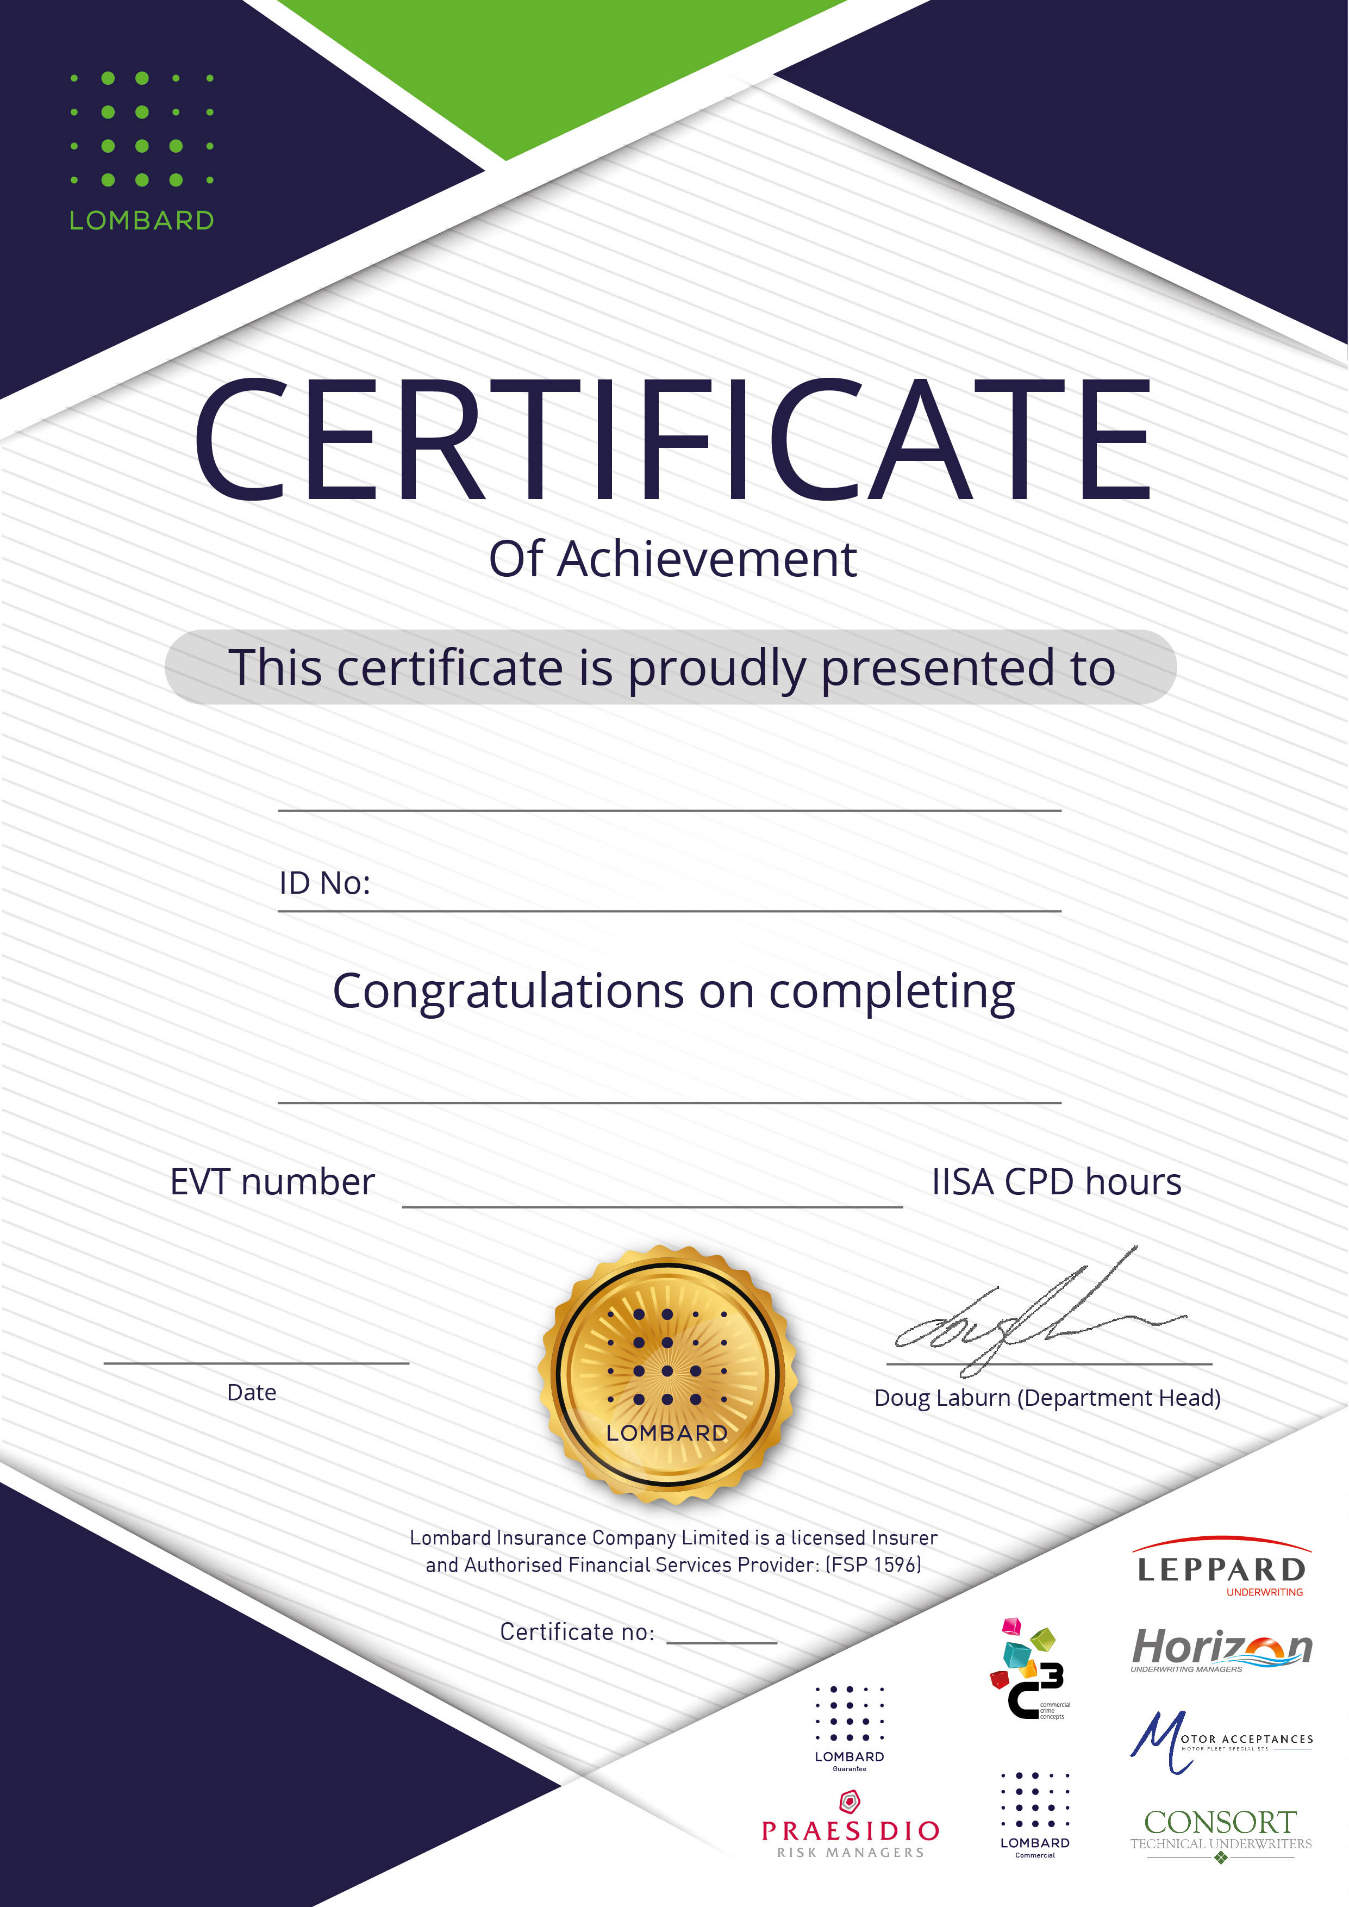
John Smith
7403445990871

xxxxxxxxxxxx

Xxxxxxxx xxxx
xxx xxxx

12

